SINGULAR AND PLURAL NOUN

Number
A noun which is used for only one person or thing is said to be in the Singular Number. Example: girl, man, child, pen, table, chair etc.
A noun which is used for more than one person or thing is said to be in the Plural Number. Example: girls, men, children, pens tables, chairs etc.

RULES :
Rule 1: Most Singular Nouns form their Plurals by adding –s.
Example:
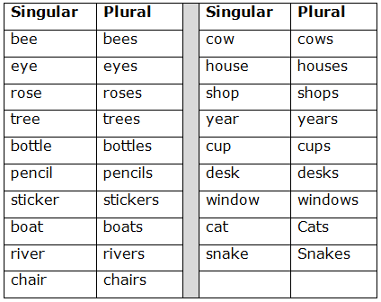

Rule 2: Nouns that ends in –s, -ss, -x, -sh, or –ch form their Plurals by adding –es to the Singular
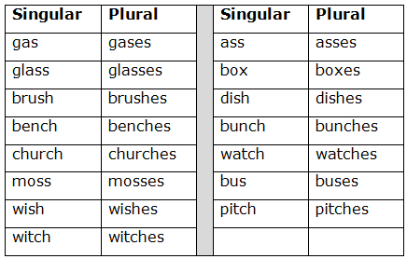

Rule 3: Noun that ends in –y, and the –y has a consonant before it, its Plural is formed by changing –y into –ies; as,
Example:
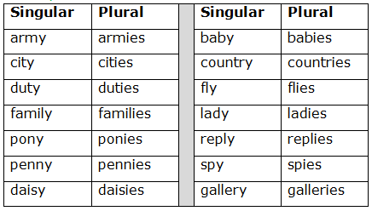
Rule 4: But if the Noun ends in –y, and the –y has a vowel before it, its Plural is formed by adding –s to the Singular
Example:
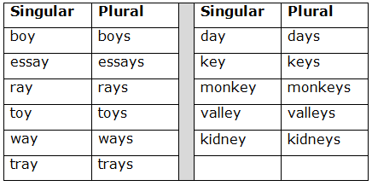
Rule 5: Noun that ends in –f or –fe form their Plurals by changing –f or –fe into –ves
Example:
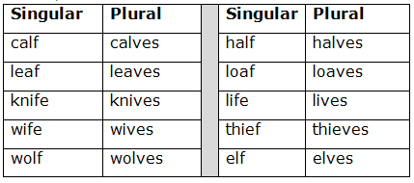
But the following Nouns form their Plurals by simply adding –s to the Singular

Example:
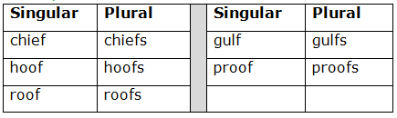
Rule 6: Nouns that ends in –o, if they have a consonant before them, generally form their Plurals by adding –es to the Singular
Example:
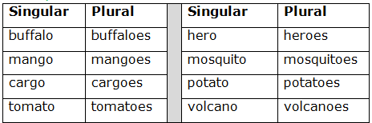
Rule 7: The following Nouns form their Plurals by a change of the inside vowel
Example:
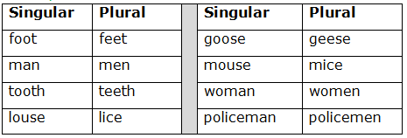
Rule 8: The following Nouns form their Plurals in –en or –ren
Example:
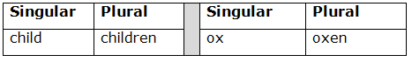
Rule 9: Compound Noun and their Plurals
Example:
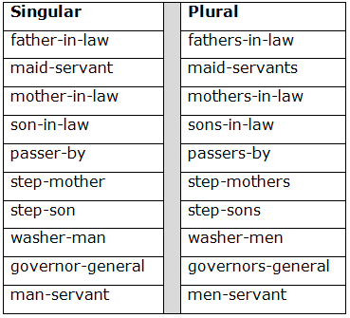
Rule 10: The following Nouns have the same form for the Plural as for the Singular.

Example:
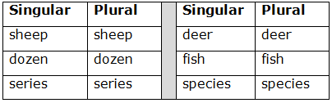

Rule 11: The following Nouns are always Singular:
Example:
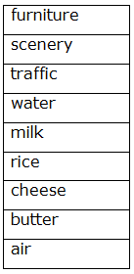
Rule 12: The following Nouns are always Plural:

Example:

Rule 13: When the subject changes from Singular to Plural the Predicate of the sentence must change too.
Example:
